IOT Based Smart Home using WPA Security & Radius Server

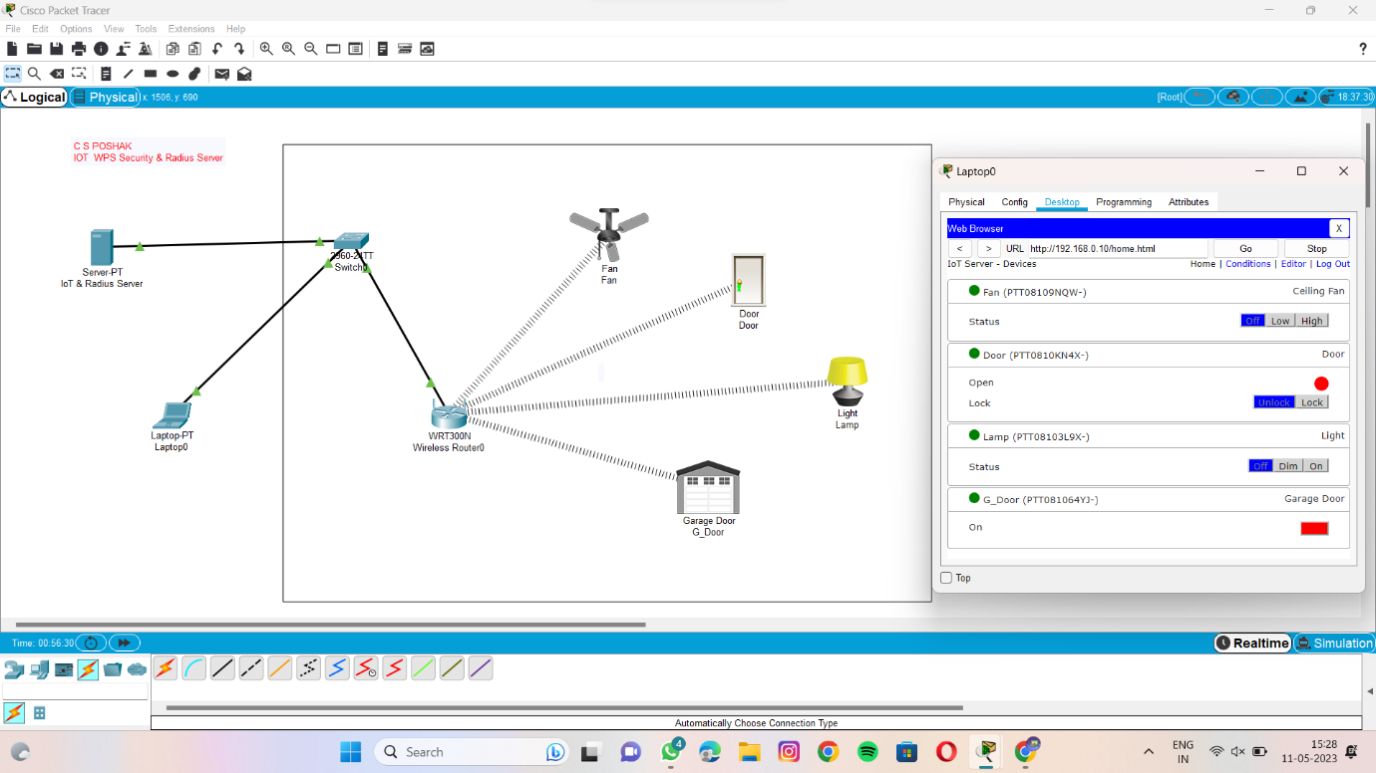

Status of Fan, Door, Lamp, G_Door is off

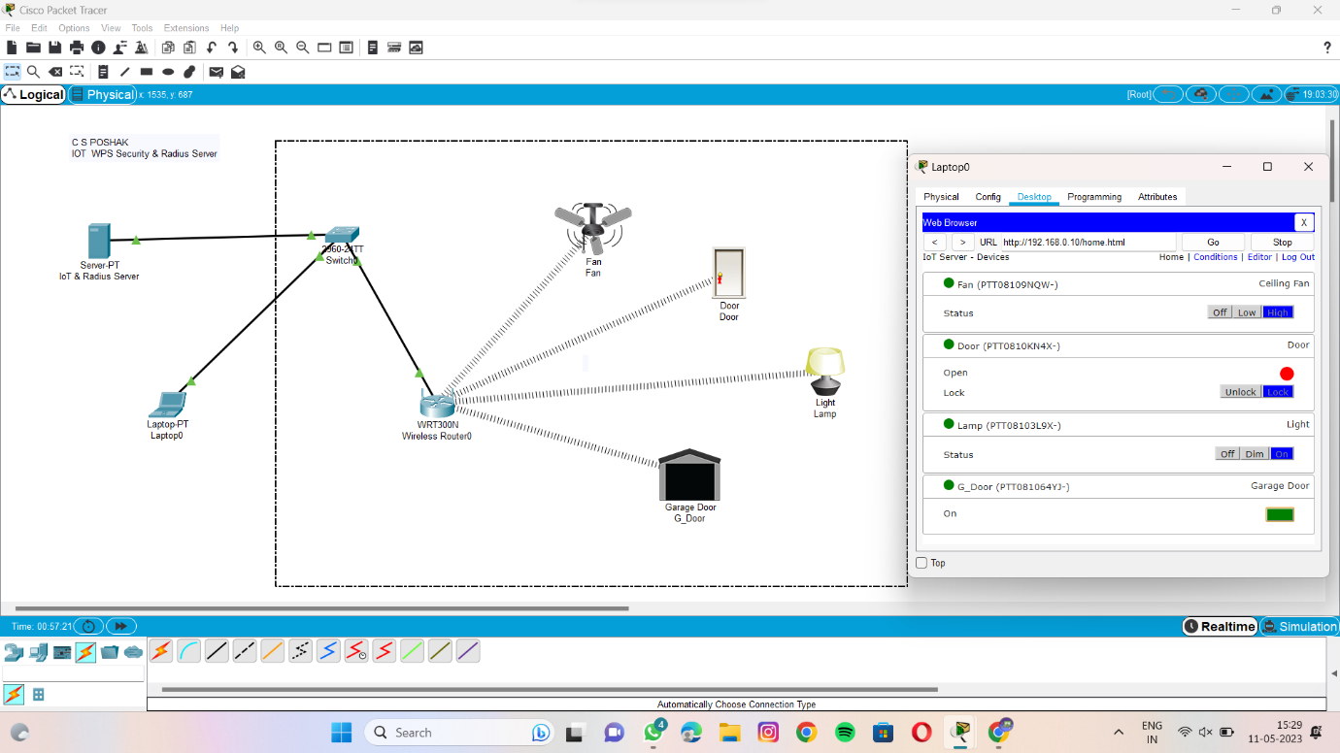

Status of fan is high & door & lamp is on, g_door is close

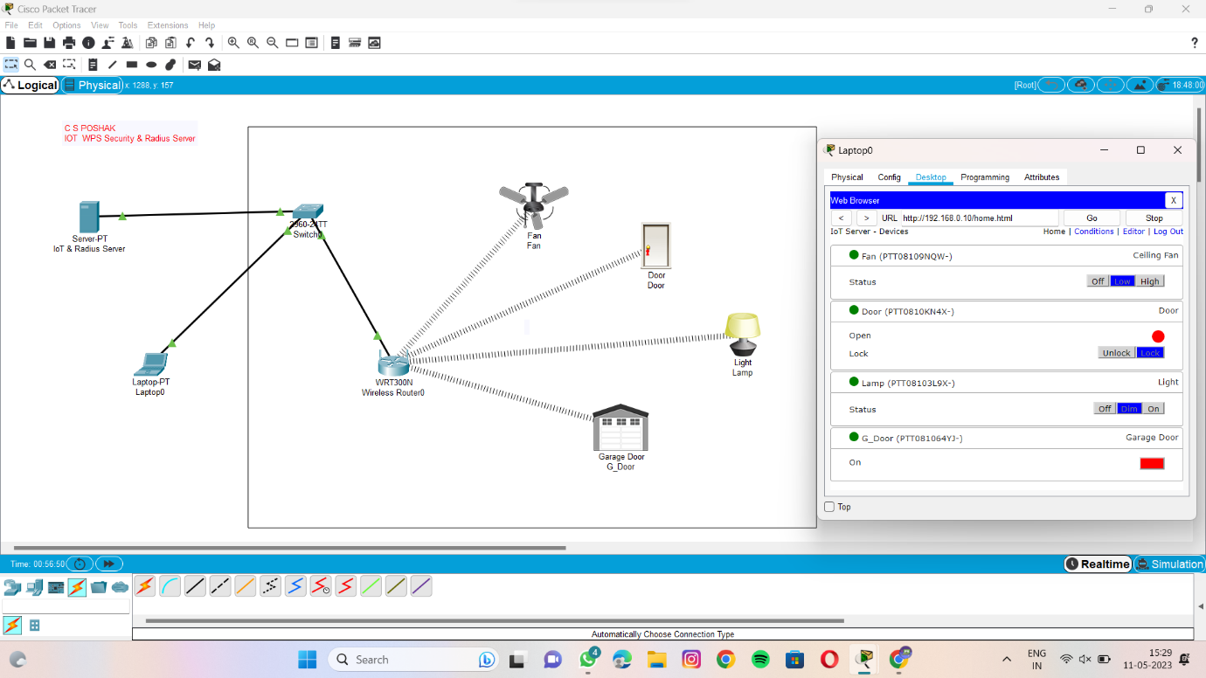

Status of fan is low & lamp is dim, door & g door is open